**Git Assignment Day-1**

**Git Install**

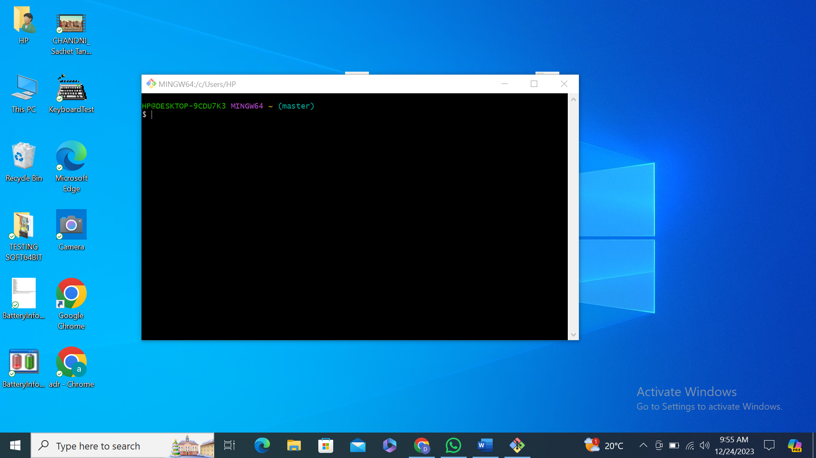

**Git Commands**

git config --global user.name "devendar"

git config --global user.email "avuthudevendarreddy2001@gmail.com

mkdir gitd22

cd gitd22

git init

touch sample.java original.java duplicate.java

git add touch sample.java original.java duplicate.java

git commit -m “first commit”

git log

git show

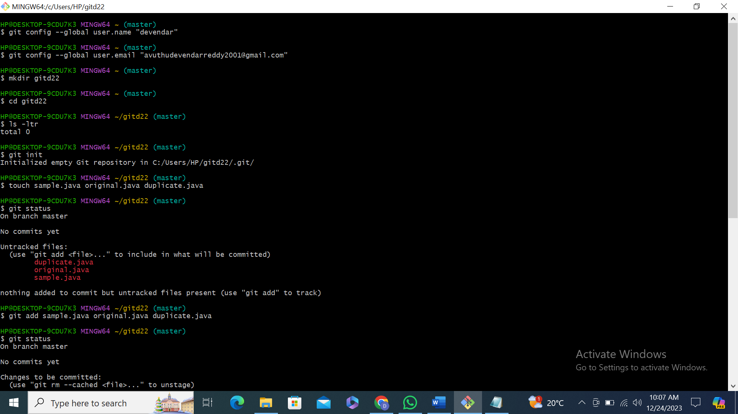

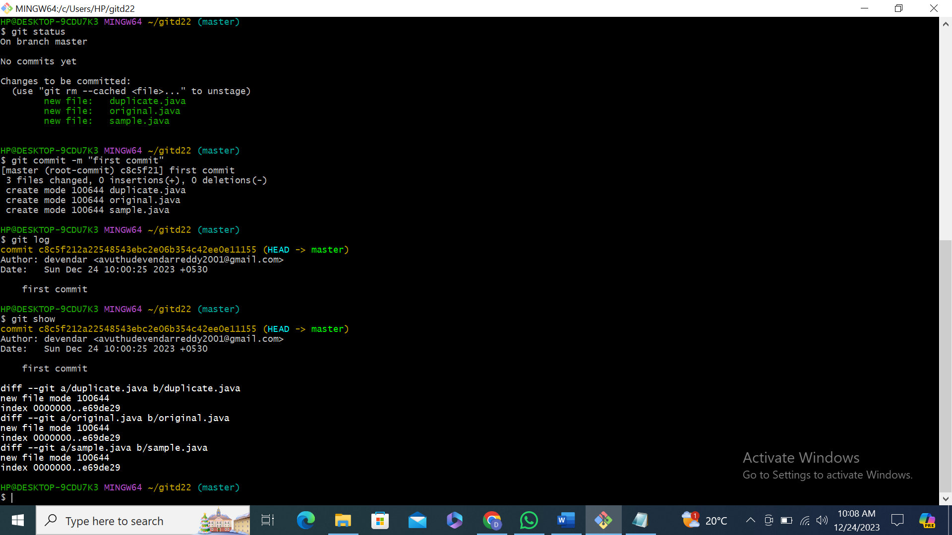

GIT HUB

goto https://github.com/

Cretae account and Signin to the https://github.com/

create repository

